**Module 8: Portfolio Milestone**

Maurice Henning

Colorado State University Global

CSC500-1: Principals of Programming

Dr. Steven Evans

May 12, 2024

**Portfolio Project**

In this final module, I will recap the steps I took for the creation of an online shopping

cart.

Steps 1-3: The first request was to build a class labeled ItemToPurchase with the following

specifications. A class is a blueprint to create objects. In this instance, we create the

following objects related to purchase items. These refer to the item name, item price, and item

quantity. Each object is labeled as item_name, item_price, and item_quantity. They were then

initialized in what is known as the default constructor. A default constructor is a unique method

that creates an object when called. The purpose is to assign values to the data members within

the class when an object is initialized, according to ShikshaOnline (2023). The constructor

always begins with __init__. Our objects are initialized with either none or 0. Then, we defined a

new object labeled item_cost and assigned a zero value to calculate the formula when the items

were printed out mathematically.

Milestone 2: Steps 4-7: The following series requested the creation of a ShoppingCart class;

however, unlike the previous ItemToPurchase class, this will be initialized with what is known as

a parameterized constructor. The difference is that our class can accept more arguments that

accommodate custom attribute values. The objects created for the shopping cart are respectively

labeled customer_name, current_date, and cart_items.

Then, I define a new object to add items using the parameter ItemTopurchase inside the

parenthesis. Next, I define the objects to remove and modify items in the cart. The object labeled

remove_item is created with two conditions. The first condition is the 'for' loop. Loops are just

blocks of code that will repeat a sequence of Python commands several times or continually until

a specific condition is met, such as an 'if' condition (APMonitor.com). In this scenario, the

program will continue the search for the item to remove superseded with the following

conditional 'if' statement. Meaning that if something is not valid, then it must be false. In this

instance, if nothing is in the cart, I will execute a print to return the sentence 'Item not found in

cart. Nothing removed'. I used these same principles to modify the cart items; by applying a

series of 'if statements, the application will travel line by line to see if the statements are true. If

false, the print statement displays the Item not found in cart. Nothing modified'.

Next, we define the object variable get_num_items_in_cart, returning the number of items in the

cart. The object contains no parameters.

Up next, I define the object get_cost_of_cart, determining all the costs of items. This backend

information initializes the application to print the customer name, date, items, and other relevant

details.

The last request for this step was to define an object labeled print_descriptions, which would

output each item's description. Once again, the following conditional 'if ' statement follows: true

or false if the shipping cart equals zero. Print the message 'Shopping cart is empty.'

Steps 5 through 10: This will be our main section of the coding process, which will be displayed

to the end user. I was requested to define the menu, create the object print_menu, and follow it

up with the print statements for "a - Add item to cart, r - Remove item from cart, c - Change item

quantity, i - Output items' descriptions, o - Output shopping cart, q – Quit".

In this central section, I program the application to ask for username and date, labeled

customer_name and current_date, and print out the statement. Afterward, a 'while true' condition

is specified for the print_menu object because this loop will continue until something breaks it.

The application will continue asking questions in the following instance until something

interrupts the loop. The series continues executing the menu with 'elif' conditional statements.

The best explanation is if you don't select 'a' to add an item in the menu prompt, then you would

select 'r' to remove an item, and this continues onward. Each letter from the menu will continue

until the letter 'q' option indicates it to quit the application. Satisfying all the requests of the

shopping cart, I close out the application, enabling the option to run code when importing into

another Python file with the 'if' condition if__name__== 'main'__':

**FINAL RESULT**

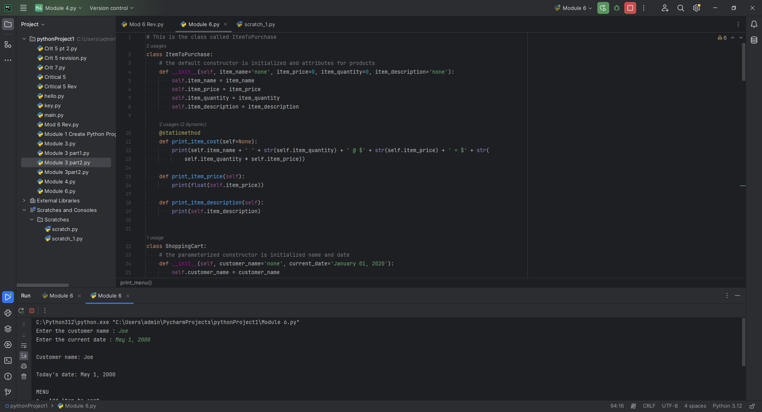

I modified the code several times, eliminating all major issues that could have prevented the

program from executing correctly. Errors like trackbacks, not declaring values or simple format

errors were resolved. There was a weak error produced by Pycharm because the program

preferred a lower-case object named variable; however, the assignment called for the label

ItemToPurchase.

See below:

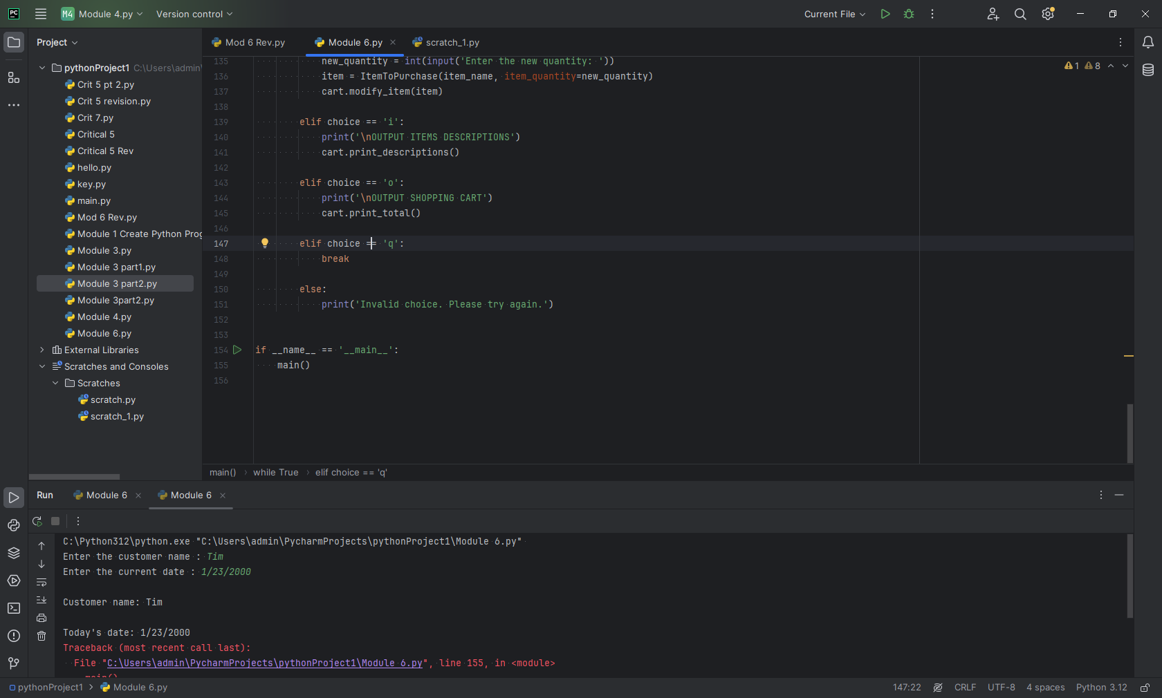

**Pseudocode**

1: **INIT** class Item to Purchase

2: **SET** initialization for item attributes; name, price, quantity, description

3. **INIT** class Shopping Cart

4. **SET** customer name, date, items all variables associated with the shopping cart

5: **DEFINE** item cost

6. **DISPLAY** name, cost, and price

7. **INIT** class shopping cart condition followed by a series of **ELIF** statements

8. **DEFINE** add item

9. **DEFINE** remove item IF cart empty **DISPLAY** item not found

10. **DEFINE** modify item, IF no items in cart **DISPLAY** items not found in cart.

11. **DEFINE** get cost of cart

12. **DEFINE** print total

13. **DEFINE** print description

14. **DEFINE** print menu and **DISPLAY** prompt

15. **DEFINE** main and **DISPLAY** user information

16. **END**

**References**

Shiksha Online . (2023, April 12) Constructors in Python: Definition, Types, and Rules

[https://www.shiksha.com/online-courses/articles/constructors-in-python-definition-types-and-rules/#:~:text=In%20Python%2C%20there%20are%20two,takes%20one%20or%20more%20arguments.](https://www.shiksha.com/online-courses/articles/constructors-in-python-definition-types-and-rules/%23:~:text=In%20Python%2C%20there%20are%20two,takes%20one%20or%20more%20arguments.)

APMonitor.com (2021) Loops in Python

<https://video-alexanderstreet-com.csuglobal.idm.oclc.org/watch/loops-in-python/details>